Chapter 11 revision name: class:

1.认识常见的acids and bases
Acids：
CH₃COOH (aq) Ethanoic acid(醋酸) H₂SO₄ (aq) Sulfuric acid (硫酸)
HNO₃ (aq) Nitric acid(硝酸) HCl (aq) Hydrochloric acid(盐酸)

Bases：
Oxides of metals：MgO magnesium oxide (氧化镁) CaO calcium oxides (氧化钙)
Hydroxides of metals (Alkali) ：Mg(OH)₂ magnesium hydroxide (氢氧化镁)
Ca(OH)₂ calcium hydroxide (氢氧化钙) NaOH sodium hydroxide (氢氧化钠)

2. 掌握物质显酸性的原因，并且能从解离的角度分辨强酸与弱酸：（ H⁺ ions）

掌握物质显碱性的原因，了解alkali 与base的区别。
Acid：the substance dissociate(解离) H⁺ (proton) when dissolved (Proton donor)
Base：the substance that gets H⁺ (proton) when dissolved (Proton accepter)
Strong acids: completely dissociate H⁺ in the solution. (HCl, H₂SO₄, HNO₃)
HCl → H⁺ + Cl⁻ 完全解离出H⁺
Weak acids : partially dissociate H⁺ in the solution (CH₃COOH)
CH3COOH ⇋ H⁺ + CH₃COO⁻ 部分解离出H+
1. Which of the following solution has the highest concentration of H⁺ ? （ ）
A. HCl(aq) with ph of 2 B. H₂SO₄ with ph of 3 C. NaOH with ph of 9

2. Which of the following solution has the lowest PH （ ）
A. HCl with 1mol/cm³ concentration of H⁺
B. H₂SO₄ with 0.002mol/dm³ concentration of H⁺
C. NaOH with 0.00002mol/dm³ concentration of H⁺
D. HNO₃ with 0.3mol/dm³ concentration of H⁺
3. Which solution has the lowest pH? （ ）
A $0.1 {\text{mol/dm}}^{3}$ sodium oxide
B $0.1 {\text{mol/dm}}^{3}$ ethanoic acid
C $0.1 {\text{mol/dm}}^{3}$ lithium hydroxide
D $0.1 {\text{mol/dm}}^{3}$ nitric acid

4. Which row shows the difference between a weak acid and a strong acid? （ ）
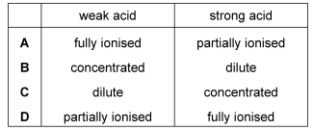

5. Please complete the reaction for dissociation of the following acids
（The first blank is for the symbol , the last is for the product)
(a) HNO₃ → H⁺ + NO₃⁻
(b) H₂SO₄ 2H⁺ +
(c) HCl H⁺ +
(d) H₂CO₃ 2H⁺ +
(e) CH₃COOH H⁺ +

3.掌握 indicator 与universal indicator 对于不同种类酸碱物质的变化。
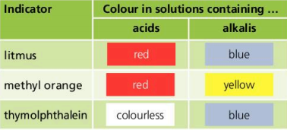
1. The colour of litmus indicator turns red when it is added to a unidentified solution, please deduce the substance in the solution from the following choices: （ ）
A. Sodium hydroxide B. Magnesium oxide C. Sulfuric acid D. Water

2. The colour of methyl orange indicator turns yellow when it is added to a unidentified solution, please deduce the substance in the solution from the following choices:（ ）
A. Sodium hydroxide B. carbon dioxide C. Sulfuric acid D. Water

3. The colour of thymolphalein indicator turns blue when it is added to a unidentified solution, please deduce the substance in the solution from the following choices:（ ）
A. Calcium hydroxide B. carbon dioxide C. Sulfuric acid D. Water

4. The colour of universal indicator turns to green when testing the solution of a substance, Which substance is likely to be the one get tested? （ ）
A. Calcium hydroxide B. carbon dioxide C. Sulfuric acid D. Water

5. The colour of universal indicator turns to red when testing the solution of a substance, Which substance is likely to be the one get tested? （ ）
A. Calcium hydroxide B. sodium oxide C. hydrochloric acid D. Water

6. The table shows the pH of four aqueous solutions, W, X, Y and Z.
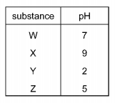
Universal Indicator is added to each solution.
Which row shows the colour of each solution after the indicator is added? （ ）
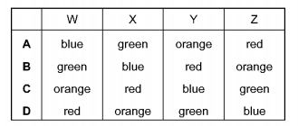

4.了解并掌握pH值对于溶液酸碱性的强弱的描述。
1. Which substance is the most acidic? （ ）
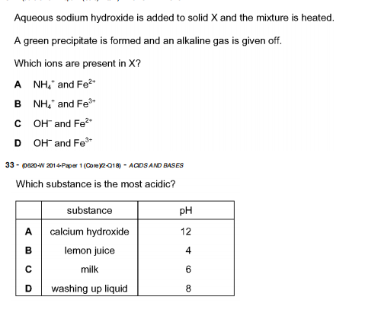
2. The graph shows how the pH of soil in a field changes over time.
At which point was the soil neutral? （ ）
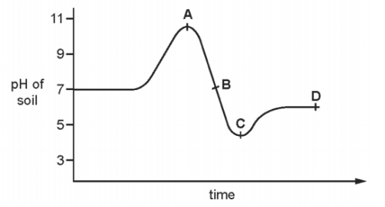
3. The graph shows how the pH of soil in a field changes over time.
At which point was the soil alkaline? （ ）


5.了解酸与碱的特征反应( Proton donor, Proton acceptor )。
Acid :
(1) React with base HCl + NaOH → H₂O + NaCl
Ionic equation： 2H⁺ + O²⁻ → H₂O
H⁺ + OH⁻ → H₂O
(2) React with carbonate 2HCl + CaCO₃ → CaCl₂ + CO₂ + H₂O
Ionic equation： 2H⁺ + CO₃²⁻ → H₂O + CO₂
(3) React with metal (active) 2HCl + Zn → ZnCl₂ + H₂
Ionic equation： 2H⁺ + metal⁻ → H₂ + metal ion
注意酸不能与inactive metal ： Cu， Ag 反应。

Base :
(1) React with acid HCl + NaOH → H₂O + NaCl
Ionic equation： H⁺ + OH⁻ → H₂O
(2) React with ammonium salt NH₄Cl + NaOH → NH₃ + H₂O
Ionic equation： NH₄⁺ + OH⁻ → H₂O + NH₃
NH₃ 是唯一的碱性气体，会导致湿润的石蕊试纸变蓝
1. A gas is escaping from a pipe in a chemical plant.
A chemist tests this gas and finds that it is alkaline.
What is this gas? （ ）
A ammonia
B chlorine
C hydrogen
D sulfur dioxide

2. The diagram shows two substances, X and Y, being heated together.
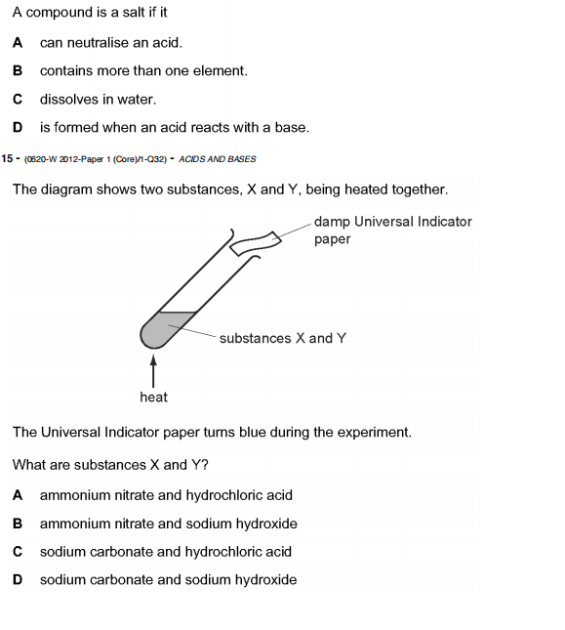
The Universal Indicator paper turns blue during the experiment.
What are substances X and Y? （ ）
A ammonium nitrate and hydrochloric acid
B ammonium nitrate and sodium hydroxide
C sodium carbonate and hydrochloric acid
D sodium carbonate and sodium hydroxide

3. Which statement about the reaction of acids is correct? （ ）
A They react with ammonium salts to form a salt and ammonia only.
B They react with metal carbonates to give a salt and carbon dioxide only.
C They react with metal hydroxides to give a salt and water only.
D They react with metals to give a salt, hydrogen and water only.

4. Which are properties of an acid? （ ）
1 reacts with ammonium sulfate to form ammonia
2 turns red litmus blue
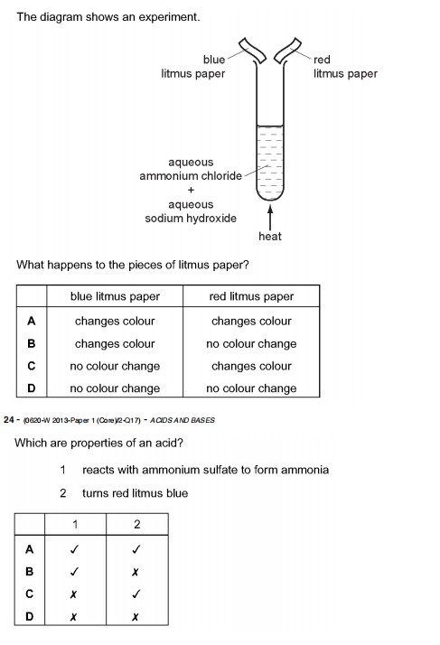
5. Which statements about alkalis are correct? （ ）
1 When reacted with an acid, the pH of the alkali increases.
2 When tested with litmus, the litmus turns blue.
3 When warmed with an ammonium salt, ammonia gas is given off.
A 1, 2 and 3 B 1 and 2 only C 1 and 3 only D 2 and 3 only

6. Which reaction is not characteristic of an acid? （ ）
A It dissolves magnesium oxide.
B It produces ammonia from ammonium compounds.
C It produces carbon dioxide from a carbonate.
D It produces hydrogen from zinc metal.

7. What is not a typical characteristic of acids? （ ）
A They react with alkalis producing water.
B They react with all metals producing hydrogen.
C They react with carbonates producing carbon dioxide.
D They turn blue litmus paper red.

6.了解如何选择制备盐的原料(舞伴规则)。
舞伴定律：制备盐，就是将盐中的离子结合起来；原料中两个离子的舞伴可以自动结合。
Zn + Cl → ZnCl₂

可以自由结合的离子对： H⁺ + OH⁻ → H₂O
2H⁺ + CO₃²⁻ → CO₂ + H₂O
2H⁺ + active metal → H₂ + metal ion
OH⁻ + NH₄⁺ → NH₃ + H₂O

1. Which acid reacts with ammonia to produce the salt ammonium sulfate? （ ）
A hydrochloric B nitric C phosphoric D sulfuric

2. Which methods are suitable for preparing both zinc sulfate and copper(II) sulfate? （ ）
1 reacting the metal oxide with warm dilute aqueous sulfuric acid
2 reacting the metal with dilute aqueous sulfuric acid
3 reacting the metal carbonate with dilute aqueous sulfuric acid
A 1,2 and 3 B 1 and 2 only C 1 and 3 only D 2 and 3 only

3. Which two compounds would react together to form insoluble salt lead(II) chloride?（ ）
 | compound | solubility in water
1 | lead(II) nitrate | yes
2 | lead(II) sulfate | no
3 | silver chloride | no
4 | sodium chloride | yes
A 1 and 3 B 1 and 4 C 2 and 3 D 2 and 4

8. Which method is used to make the salt copper sulfate? （ ）
A dilute acid $+$ alkali
B dilute acid $+$ carbonate
C dilute acid $+$ metal
D dilute acid $+$non- metal oxide

7.了解制备可溶性盐与不可溶性盐的实验操作。
(1)Preparing soluble salt
Step 1 : Transfer and Heat the acid
Step 2 : Add excess solid
Step 3 : Filteration
Step 4 : Evaporate the water
Step 5 : Cool to crystallise

(2)Preparing insoluble salt
Step 1 : Precipitation(制作沉淀) Adding reactants .
Step 2 : Filtration
Step 3 : Rinse the residue
Step 4 : Dry the solid
盐的溶解度规则：钾、钠、铵盐、硝酸盐皆可溶，氯化物中银不溶，
硫酸盐中钡、铅不溶，碳酸、磷酸盐只溶钾、钠、铵。

不可溶的盐：AgCl, AgBr, AgI, PbI₂ , CaSO₄ ,BaSO₄, PbSO₄
Carbonates except(除了有这三个离子的碳酸盐) Na₂CO₃ ,K₂CO₃, (NH₄)₂CO₃

1. Four stages for preparation of a salt from an acid and a solid metal oxide are listed.
1 Add excess solid.
2 Evaporate half the solution and leave to cool.
3 Filter to remove unwanted solid.
4 Heat the acid.
In which order should the stages be carried out? （ ）
$$\begin{aligned}&\text{A} 1→3→4→2 \\ &\text{B} 2→1→3→4 \\ &\text{C} 4→1→3→2 \\ &\text{D} 4→2→1→3\end{aligned}$$

2. Barium sulfate is an insoluble salt.
It can be made by reacting copper(II) sulfate solution with barium nitrate solution.
$$CuSO_{4}(aq)+Ba(NO_{3})_{2}(aq)→Cu(NO_{3})_{2}(aq)+BaSO_{4}(s)$$
What is the correct order of steps to obtain a pure, dry sample of barium sulfate from the reaction mixture? （ ）
 | step 1 | step 2 | step 3
A | filter | evaporate the filtrate to dryness | leave the solid formed to cool
B | filter | evaporate the filtrate to the point of crystallisation | leave the filtrate to cool
C | filter | leave the residue in a warm place to dry | wash the residue with water
D | filter | wash the residue with water | leave the residue in a warm place to dry

3. The solubility of some salts is shown.
 | chloride | nitrate | sulfate | carbonate
barium | soluble | soluble | insoluble | insoluble
lead(II) | insoluble | soluble | insoluble | insoluble
potassium | soluble | soluble | soluble | soluble
zinc | soluble | soluble | soluble | insoluble
Which two aqueous solutions produce an insoluble salt when mixed together?（ ）
A barium chloride and zinc nitrate
B barium nitrate and lead(II) nitrate
C lead(II) nitrate and potassium carbonate
D potassium nitrate and zinc sulfate

4. Lead(II) sulfate is an insoluble salt.
Which reaction produces a mixture from which lead(II) sulfate is obtained by filtration? （ ）
A adding solid lead(II) carbonate to dilute sulfuric acid
B adding solid lead(II) hydroxide to dilute sulfuric acid
C adding metallic lead to dilute sulfuric acid
D adding aqueous lead(II) nitrate to dilute sulfuric acid

8.了解acidic oxide，basic oxide与amphoteric oxide的定义，并能从元素构成角度辨别oxide的种类。
Acidic oxide: The oxides that react with water to form an acid.(oxides of non-metals)
Basic oxide:The oxides that react with acid to form salt and water (oxides of metals)
Amphoteric oxide:The oxides that can react with both acids and alkalis (Al₂O₃,ZnO)
Neutral oxide:The oxide that do not react with neither acids nor alkalis
1. Air containing an acidic impurity was neutralised by passing it through a column containing substance X.
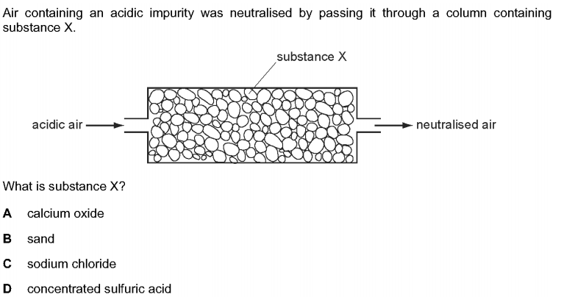
What is substance X? （ ）
A calcium oxide
B sand
C sodium chloride
D concentrated sulfuric acid

2. Two oxides, X and Y, are added separately to dilute H₂SO₄ and dilute NaOH
X reacts with dilute sulfuric acid but Y does not react.
Y reacts with aqueous sodium hydroxide but X does not react.
Which type of oxide are X and Y? （ ）
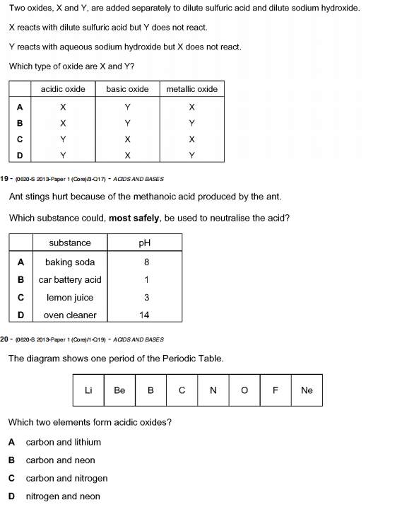

3. Germanium oxide is a white powder. （ ）
Germanium oxide reacts with concentrated hydrochloric acid.
Germanium oxide reacts with concentrated aqueous sodium hydroxide.
Germanium oxide does not dissolve when added to water.
Which type of oxide is germanium oxide?
A acidic B amphoteric C basic D neutral

4. Which of the following are properties of the oxides of non - metals? （ ）
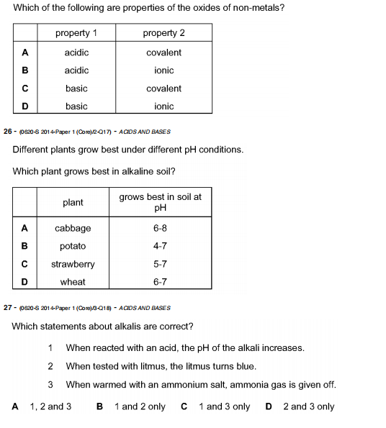

5. Element X forms an acidic, covalent oxide.
Which row shows how many electrons there could be in the outer shell of an atom of X? （ ）
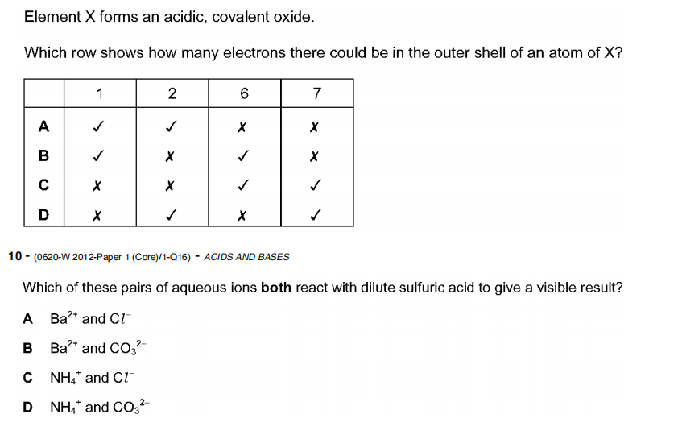
6. The diagram shows one period of the Periodic Table.

Which two elements form acidic oxides? （ ）
A carbon and lithium
B carbon and neon
C carbon and nitrogen
D nitrogen and neon
7. The diagram shows a simplified form of the Periodic Table:
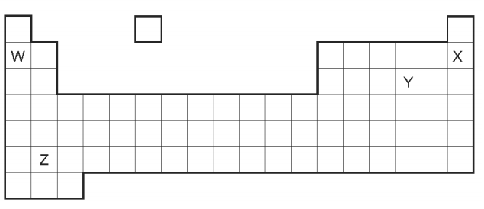
Which elements will form an acidic oxide? （ ）
A W and Z B W only C X and Y only D Y only

8. Nitrogen(I) oxide (N₂O),nitrogen(II) oxide (NO), and carbon monoxide (CO) are all oxides.
They do not react with acids or bases.
Which statement is correct? （ ）
A They are acidic oxides
B They are amphoteric oxides
C They are basic oxides
D They are neutral oxides
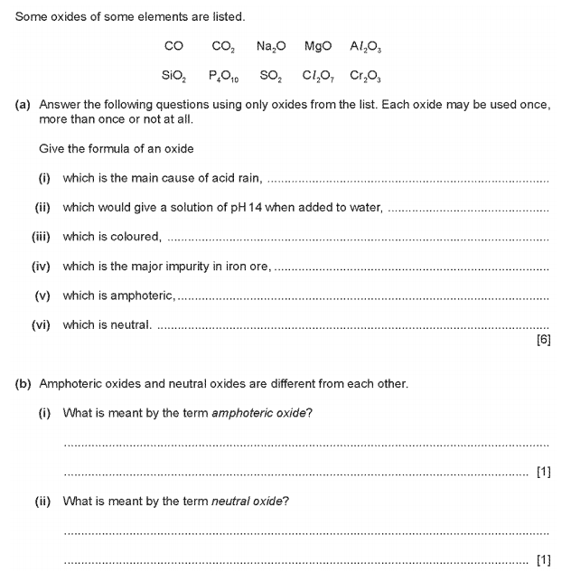

9. 了解酸碱滴定中各装置的名称与作用。
Measuring cylinder(量筒)：only roughly measure the volume of liquid(粗略测量)
Pipette(移液管)：accurately measure the fixed volume of liquid (5ml ,10ml,25ml)
(准确测量固定体积的液体)
Burette(滴定管)：accurately measure the flexible volume of liquid(24.2ml, 23.8, etc)(准确测量不固定体积的液体)
1. Which salt preparation uses a burette and a pipette? （ ）
A calcium nitrate from calcium carbonate and nitric acid
B copper(II) sulfate from copper(II) hydroxide and sulfuric acid
C potassium chloride from potassium hydroxide and hydrochloric acid
D zinc chloride from zinc and hydrochloric acid

2. Crystals of sodium chloride were prepared by the following method.
1 $25.0cm^{3}$ of dilute hydrochloric acid was accurately measured into a conical flask.
2 Aqueous sodium hydroxide was added until the solution was neutral. The volume of sodium hydroxide added was measured.
3 Solution was evaporated and crystals washed with approximately $15cm^{3}$ of water.
Which row shows the pieces of apparatus used to measure the $25.0cm^{3}$ of HCl,
the volume of aqueous sodium hydroxide and the $15cm^{3}$ of water? （ ）
 | 25.0cm³ of hydrochloric acid accurately | the volume of aqueous sodium hydroxide added | 15cm³ of water approximately
A | burette | pipette | measuring cylinder
B | measuring cylinder | burette | pipette
C | pipette | burette | measuring cylinder
D | pipette | measuring cylinder | burette

3. The four pieces of apparatus shown below are used in chemical experiments.
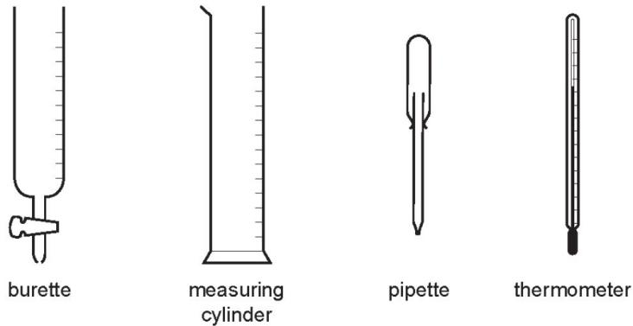
Which statement about the apparatus is correct? （ ）
A The burette measures the volume of liquid added in a titration.
B The measuring cylinder measures the mass of a substance used in an experiment.
C The pipette measures the volume of gas given off in a reaction.
D The thermometer measures the density of a solution.
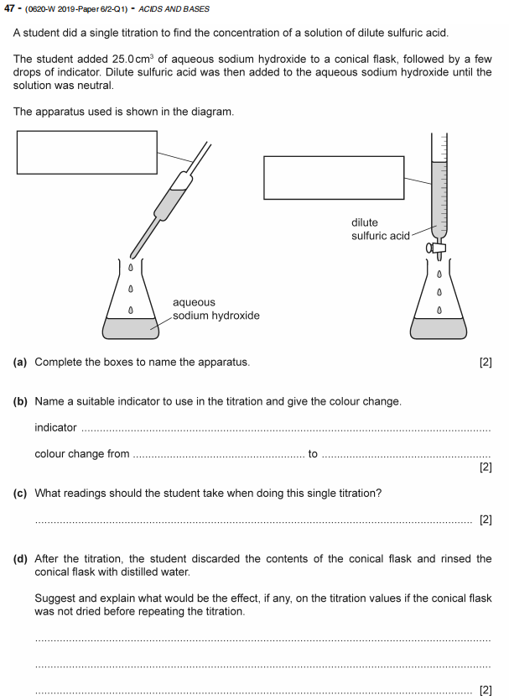


10. 了解酸碱滴定的流程
实验步骤：
Step1：Transfer 10ml of HCl with 10ml pipette
Step2：Add a few drops of the indicator(To identify when the neutralization ends )
Step3：Transfer the NaOH to the burette
Step 4: Add NaOH to the conical flask until the colour changes (End- point)
Step 5: Collect and calculate the data
Step 6: Repeat the experiment (To testify the reliability of the data.)
验证数据的可信度

1. Many window-cleaning products contain aqueous ammonia.
Aqueous ammonia is an alkali that reacts with dilute acids.
Plan an investigation to find which of two window-cleaning products contains the most concentrated aqueous ammonia.
Include in your plan:• the method you will use•
how your results will be used to determine
which window-cleaning product contains the most concentrated aqueous ammonia.
You are provided with an aqueous solution of the two window-cleaning products, dilute hydrochloric acid of known concentration and common laboratory apparatus.
.................................................................................................................................
.................................................................................................................................
.................................................................................................................................
.................................................................................................................................
.................................................................................................................................
.................................................................................................................................
.................................................................................................................................
................................................................................................................................. [6]

11. 掌握滴定中数据的获取和计算。
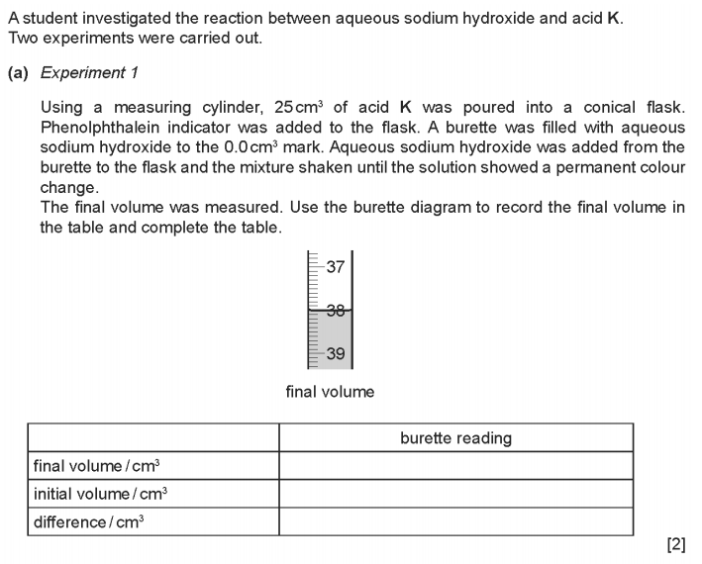
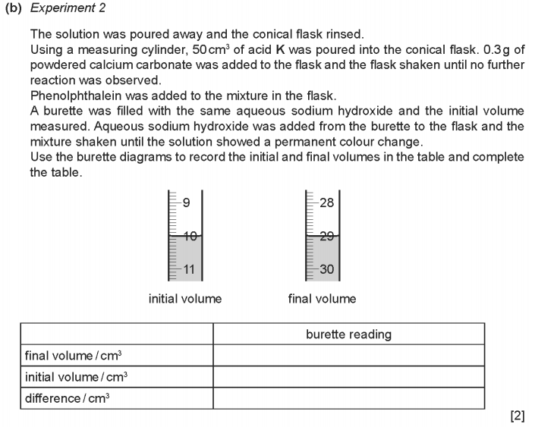
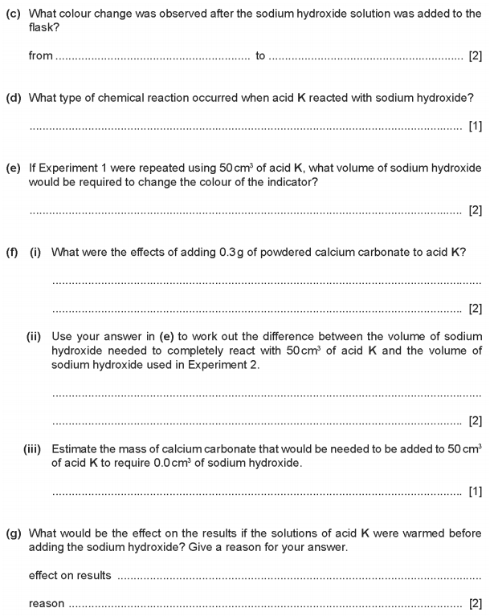

12. 了解各细节操作的用途。
注意的细节：1. Swirl the conical flask 摇晃锥形瓶：
Make sure the neutralization reaction is complete
2. Before the titration rinse the burette and pipette with distilled water
用蒸馏水润洗 目的：To remove the impurities
3. Rinsed again by the solution you will added later 用后面需要加的溶液润洗
目的：To remove distilled water.
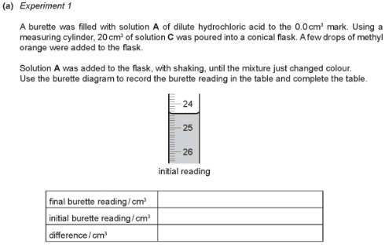
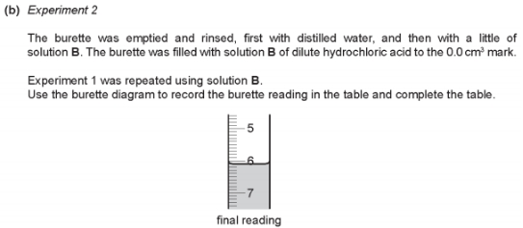
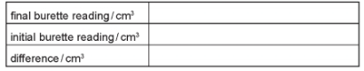
(c) (i) What type of chemical reaction takes place when hydrochloric acid reacts with alkaline solutions?.................................................................... [1]
(ii) Why is methyl orange added to the flask?............................................ [1]
(d) Why was the burette rinsed, first with distilled water and then with solution B, before starting Experiment 2?.
.......................................................................................................
.......................................................................................................[2]

